This**Python MySQL tutorial** will help to learn how to use MySQL with Python from basics to advance, including all necessary functions and queries explained in detail with the help of good Python MySQL examples. So, let’s get started.

**Installation**

To install the **Python-mysql-connector** module, one must have Python and PIP, preinstalled on their system. If Python and pip are already installed type the below command in the terminal.

pip3 install mysql-connector-python

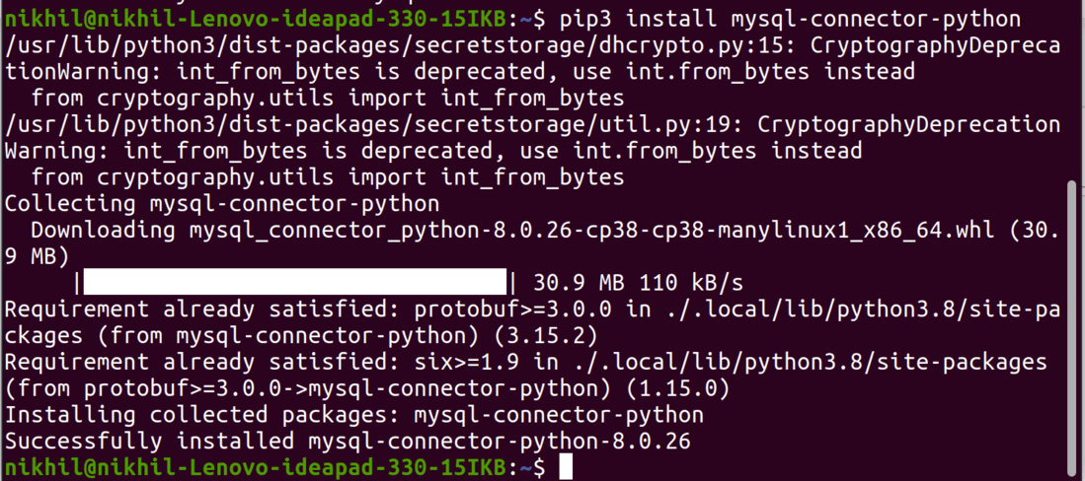

**Connecting to MySQL Server**

We can connect to the MySQL server using the connect() method.

* Python3

|  |
| --- |
| # importing required libraries  import mysql.connector  dataBase = mysql.connector.connect(    host ="localhost",    user ="user",    passwd ="password"  )  print(dataBase)  # Disconnecting from the server  dataBase.close() |

**Output:**

*<mysql.connector.connection_cext.CMySQLConnection object at 0x7f73f0191d00>*

**Creating Database**

After connecting to the MySQL server let’s see how to create a MySQL database using Python. For this, we will first create a cursor() object and will then pass the SQL command as a string to the execute() method. The SQL command to create a database is –

CREATE DATABASE DATABASE_NAME

**Example: Creating MySQL database with Python**

* Python3

|  |
| --- |
| # importing required libraries  import mysql.connector  dataBase = mysql.connector.connect(    host ="localhost",    user ="user",    passwd ="password"  )  # preparing a cursor object  cursorObject = dataBase.cursor()  # creating database  cursorObject.execute("CREATE DATABASE gfg") |

**Output:**

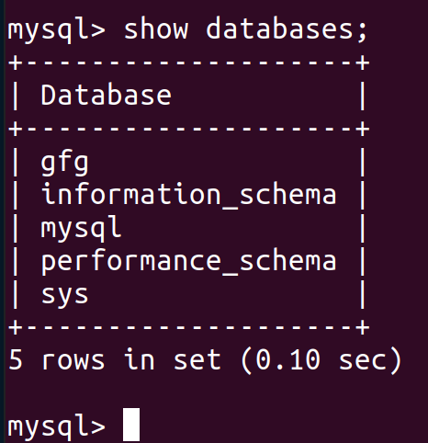

**Creating Tables**

For [creating tables](https://www.geeksforgeeks.org/python-mysql-create-table/) we will follow the similar approach of writing the SQL commands as strings and then passing it to the execute() method of the cursor object. SQL command for creating a table is –

CREATE TABLE

(

column_name_1 column_Data_type,

column_name_2 column_Data_type,

:

:

column_name_n column_Data_type

);

**Example: Creating MySQL table using Python**

* Python3

|  |
| --- |
| # importing required libraries  import mysql.connector  dataBase = mysql.connector.connect(    host ="localhost",    user ="user",    passwd ="password",    database = "gfg"  )  # preparing a cursor object  cursorObject = dataBase.cursor()  # creating table  studentRecord = """CREATE TABLE STUDENT (                     NAME  VARCHAR(20) NOT NULL,                     BRANCH VARCHAR(50),                     ROLL INT NOT NULL,                     SECTION VARCHAR(5),                     AGE INT                     )"""  # table created  cursorObject.execute(studentRecord)  # disconnecting from server  dataBase.close() |

**Output:**

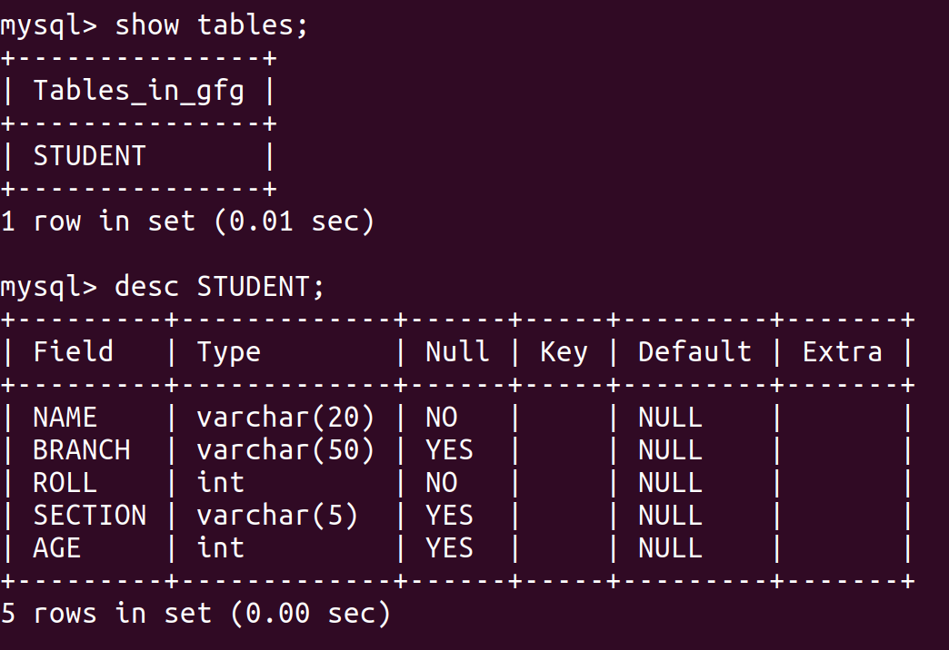

**Insert Data into Tables**

To insert data into the MySQL table **Insert into**query is used.

**Syntax:**

INSERT INTO table_name (column_names) VALUES (data)

**Example 1: Inserting Single Row**

* Python3

|  |
| --- |
| # importing required libraries  import mysql.connector  dataBase = mysql.connector.connect(    host ="localhost",    user ="user",    passwd ="password",    database = "gfg"  )  # preparing a cursor object  cursorObject = dataBase.cursor()  sql = "INSERT INTO STUDENT (NAME, BRANCH, ROLL, SECTION, AGE)\  VALUES (%s, %s, %s, %s, %s)"  val = ("Ram", "CSE", "85", "B", "19")  cursorObject.execute(sql, val)  dataBase.commit()  # disconnecting from server  dataBase.close() |

**Output:**

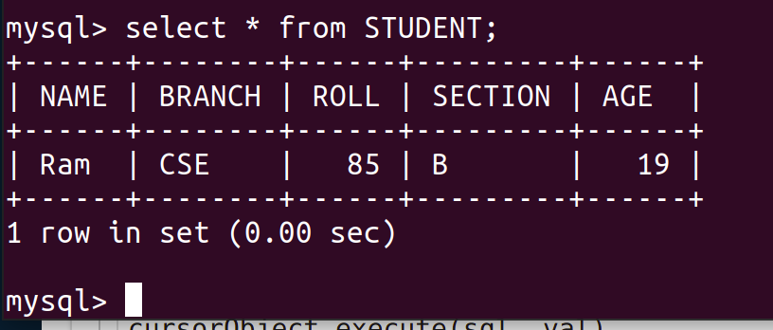

**Example 2: Inserting Multiple Rows**

To insert multiple values at once, executemany() method is used. This method iterates through the sequence of parameters, passing the current parameter to the execute method.

* Python3

|  |
| --- |
| # importing required libraries  import mysql.connector  dataBase = mysql.connector.connect(    host ="localhost",    user ="user",    passwd ="password",    database = "gfg"  )  # preparing a cursor object  cursorObject = dataBase.cursor()  sql = "INSERT INTO STUDENT (NAME, BRANCH, ROLL, SECTION, AGE)\  VALUES (%s, %s, %s, %s, %s)"  val = [("Nikhil", "CSE", "98", "A", "18"),         ("Nisha", "CSE", "99", "A", "18"),         ("Rohan", "MAE", "43", "B", "20"),         ("Amit", "ECE", "24", "A", "21"),         ("Anil", "MAE", "45", "B", "20"),         ("Megha", "ECE", "55", "A", "22"),         ("Sita", "CSE", "95", "A", "19")]     cursorObject.executemany(sql, val)  dataBase.commit()  # disconnecting from server  dataBase.close() |

**Output:**

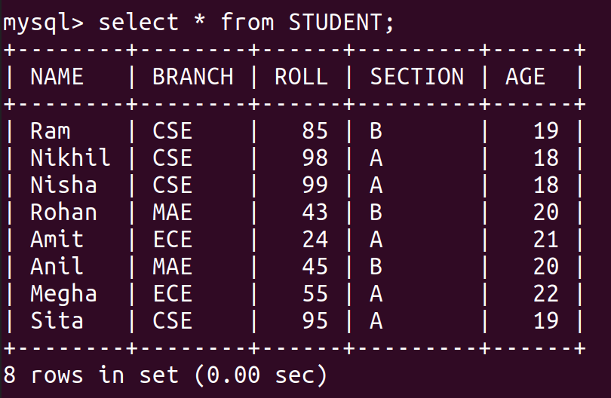

**Fetching Data**

We can use the select query on the MySQL tables in the following ways –

* In order to select particular attribute columns from a table, we write the attribute names.

SELECT attr1, attr2 FROM table_name

* In order to select all the attribute columns from a table, we use the asterisk ‘*’ symbol.

SELECT * FROM table_name

**Example: Select data from MySQL table using Python**

* Python3

|  |
| --- |
| # importing required libraries  import mysql.connector  dataBase = mysql.connector.connect(    host ="localhost",    user ="user",    passwd ="password",    database = "gfg"  )  # preparing a cursor object  cursorObject = dataBase.cursor()  query = "SELECT NAME, ROLL FROM STUDENT"  cursorObject.execute(query)  myresult = cursorObject.fetchall()  for x in myresult:      print(x)  # disconnecting from server  dataBase.close() |

**Output:**

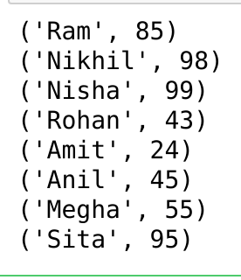

**Where Clause**

Where clause is used in MySQL database to filter the data as per the condition required. You can fetch, delete or update a particular set of data in MySQL database by using where clause.

**Syntax:**

*SELECT column1, column2, …. columnN FROM [TABLE NAME] WHERE [CONDITION];*

**Example: Where clause in MySQL using Python**

* Python3

|  |
| --- |
| # importing required libraries  import mysql.connector  dataBase = mysql.connector.connect(    host ="localhost",    user ="user",    passwd ="password",    database = "gfg")  # preparing a cursor object  cursorObject = dataBase.cursor()  query = "SELECT * FROM STUDENT where AGE >=20"  cursorObject.execute(query)  myresult = cursorObject.fetchall()  for x in myresult:      print(x)  # disconnecting from server  dataBase.close() |

**Output:**

('Rohan', 'MAE', 43, 'B', 20)

('Amit', 'ECE', 24, 'A', 21)

('Anil', 'MAE', 45, 'B', 20)

('Megha', 'ECE', 55, 'A', 22)

**Order By Clause**

OrderBy is used to arrange the result set in either ascending or descending order. By default, it is always in ascending order unless “DESC” is mentioned, which arranges it in descending order. “ASC” can also be used to explicitly arrange it in ascending order. But, it is generally not done this way since default already does that.

**Syntax:**

SELECT column1, column2

FROM table_name

ORDER BY column_name ASC|DESC;

**Example: Order By clause in MySQL using Python**

* Python3

|  |
| --- |
| # importing required libraries  import mysql.connector  dataBase = mysql.connector.connect(    host ="localhost",    user ="user",    passwd ="password",    database = "gfg"  )  # preparing a cursor object  cursorObject = dataBase.cursor()  query = "SELECT * FROM STUDENT ORDER BY NAME DESC"  cursorObject.execute(query)    myresult = cursorObject.fetchall()  for x in myresult:      print(x)  # disconnecting from server  dataBase.close() |

**Output:**

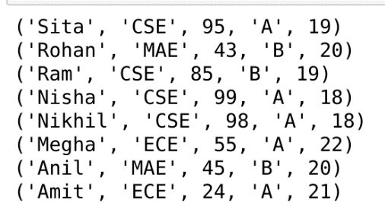

**Limit Clause**

The Limit clause is used in SQL to control or limit the number of records in the result set returned from the query generated. By default, SQL gives out the required number of records starting from the top but it allows the use of OFFSET keyword. OFFSET allows you to start from a custom row and get the required number of result rows.

**Syntax:**

SELECT * FROM tablename LIMIT limit;

SELECT * FROM tablename LIMIT limit OFFSET offset;

**Example: Limit Clause in MySQL using Python**

* Python3

|  |
| --- |
| # importing required libraries  import mysql.connector    dataBase = mysql.connector.connect(    host ="localhost",    user ="user",    passwd ="password",    database = "gfg"  )   # preparing a cursor object  cursorObject = dataBase.cursor()  query = "SELECT * FROM STUDENT LIMIT 2 OFFSET 1"  cursorObject.execute(query)  myresult = cursorObject.fetchall()   for x in myresult:      print(x)   # disconnecting from server  dataBase.close() |

**Output:**

('Nikhil', 'CSE', 98, 'A', 18)

('Nisha', 'CSE', 99, 'A', 18)

**Update Data**

The update query is used to change the existing values in a database. By using update a specific value can be corrected or updated. It only affects the data and not the structure of the table. The basic advantage provided by this command is that it keeps the table accurate.

**Syntax:**

UPDATE tablename

SET ="new value"

WHERE ="old value";

**Example: Update MySQL table using Python**

* Python3

|  |
| --- |
| # importing required libraries  import mysql.connector  dataBase = mysql.connector.connect(    host ="localhost",    user ="user",    passwd ="password",    database = "gfg"  )  # preparing a cursor object  cursorObject = dataBase.cursor()  query = "UPDATE STUDENT SET AGE = 23 WHERE Name ='Ram'"  cursorObject.execute(query)  dataBase.commit()  # disconnecting from server  dataBase.close() |

**Output:**

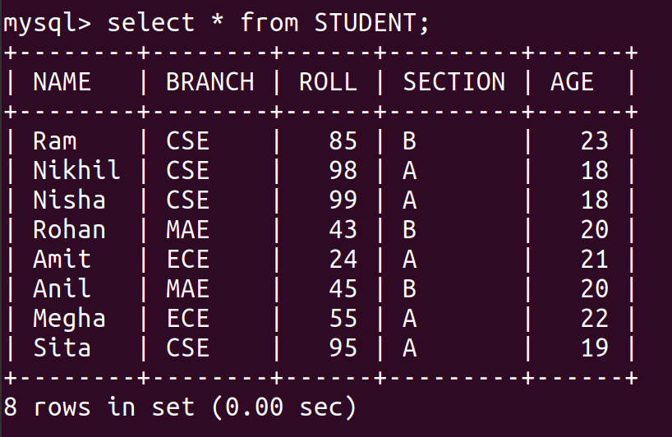

**Delete Data from Table**

We can use the [Delete query](https://www.geeksforgeeks.org/python-mysql-delete-query/) to delete data from the table in MySQL.

**Syntax:**

DELETE FROM TABLE_NAME WHERE ATTRIBUTE_NAME = ATTRIBUTE_VALUE

**Example: Delete Data from MySQL table using Python**

* Python3

|  |
| --- |
| # importing required libraries  import mysql.connector  dataBase = mysql.connector.connect(    host ="localhost",    user ="user",    passwd ="password",    database = "gfg"  )  # preparing a cursor object  cursorObject = dataBase.cursor()  query = "DELETE FROM STUDENT WHERE NAME = 'Ram'"  cursorObject.execute(query)  dataBase.commit()  # disconnecting from server  dataBase.close() |

**Output:**

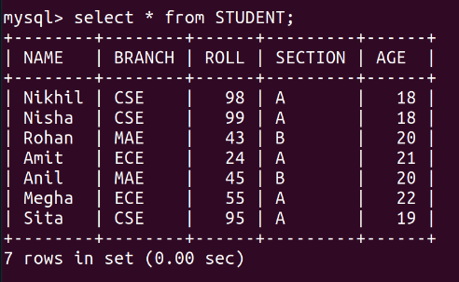

**Drop Tables**

Drop command affects the structure of the table and not data. It is used to delete an already existing table. For cases where you are not sure if the table to be dropped exists or not DROP TABLE IF EXISTS command is used. Both cases will be dealt with in the following examples.

**Syntax:**

DROP TABLE tablename;

DROP TABLE IF EXISTS tablename;

At first, let’s see the list of tables in our database.

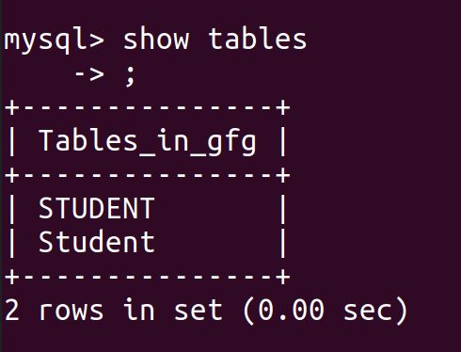

We can see that there are two tables for students, so let’s drop the second table.

**Example 1: Drop Table in MySQL using Python**

* Python3

|  |
| --- |
| # importing required libraries  import mysql.connector  dataBase = mysql.connector.connect(    host ="localhost",    user ="user",    passwd ="password",    database = "gfg"  )  # preparing a cursor object  cursorObject = dataBase.cursor()  query ="DROP TABLE Student;"  cursorObject.execute(query)  dataBase.commit()  # disconnecting from server  dataBase.close() |

**Output:**

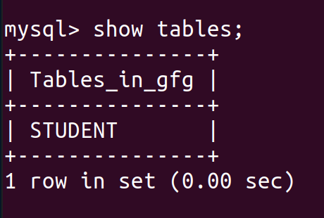

**Example 2: Drop Table if exists**

* Python3

|  |
| --- |
| # importing required libraries  import mysql.connector  dataBase = mysql.connector.connect(    host ="localhost",    user ="user",    passwd ="password",    database = "gfg"  )  # preparing a cursor object  cursorObject = dataBase.cursor()    query ="Drop Table if exists Employee;"  cursorObject.execute(query)  dataBase.commit()  # disconnecting from server  dataBase.close() |

The above example, will not create any error and output because we have used the Drop Table is exists query. If we will simply use the Drop table Employee then **ProgrammingError: 1051 (42S02): Unknown table ‘gfg.Employee’** is raised.